**FIR LANE METH0DIST CHURCH**

**ROYTON OL2 6XU**

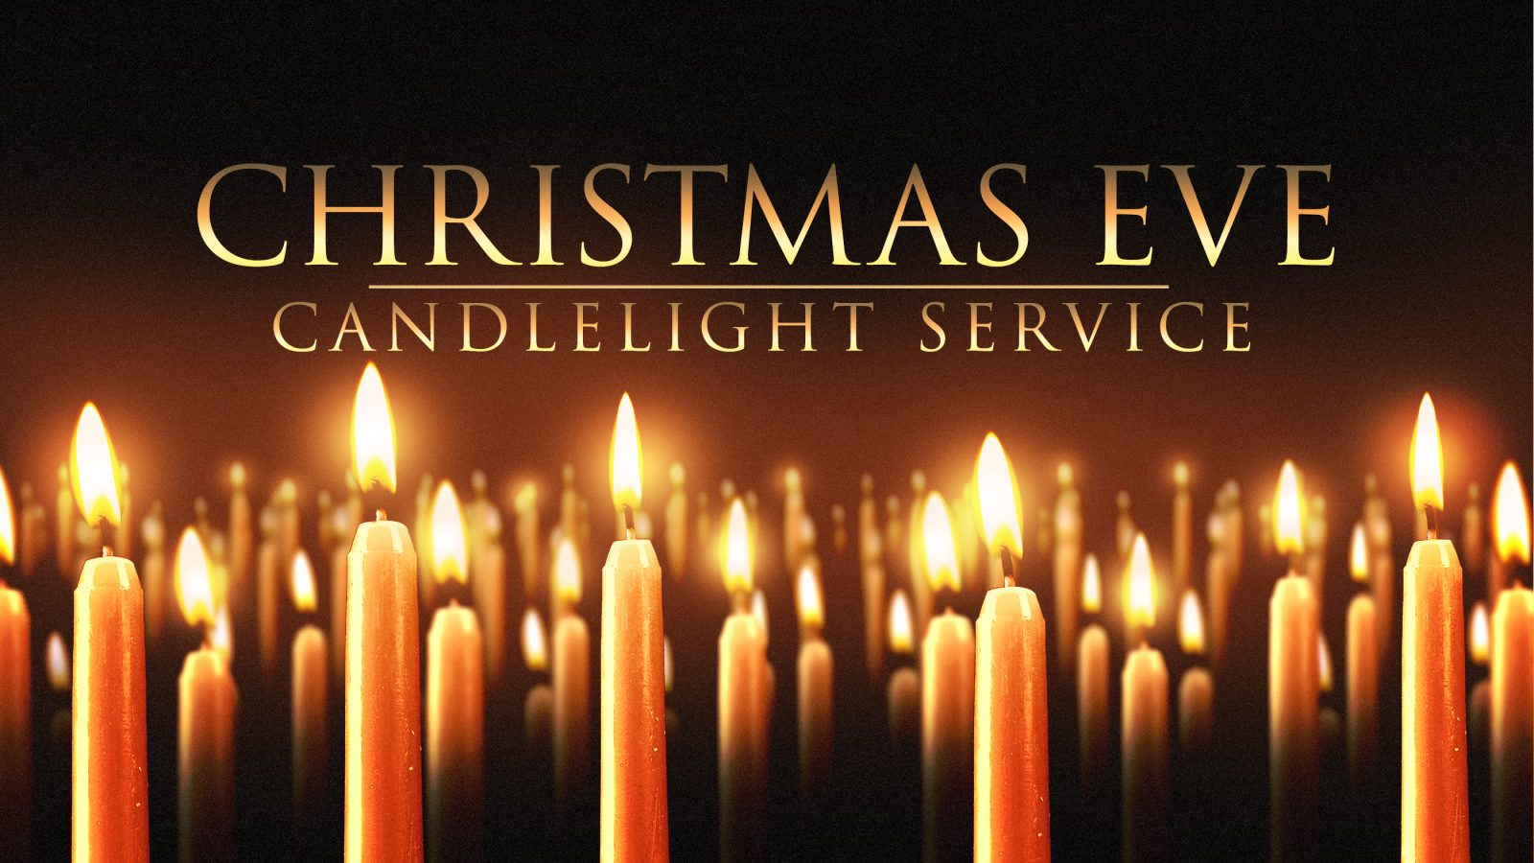

**24THDECEMBER 6.30PM**



**COME AND CELEBRATE THIS**

**SPECIAL TIME WITH FAMILY & FRIENDS**