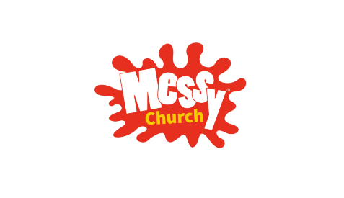
The Methodist Church in Royton
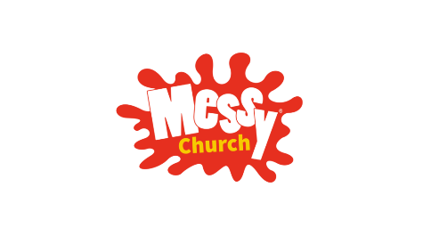
at TRINITY METHODIST CHURCH
Radcliffe Street, Royton, Oldham, OL2 5QR
Christmas
MESSY CHURCH
for families & individuals of all ages
SUNDAY
15th DECEMBER 2024
4pm to 6pm
Christmas activities, crafts & worship suitable for all ages.
Turkey Sandwiches & alternative vegetarian/vegan option.
FREE
entry, all activities and supper are free of charge
ALL ARE WELCOME
We look forward to welcoming YOU to our Messy Church session

Our next Messy Church will be on Sunday 16th February 2025
Trinity Methodist Church, Radcliffe Street, Royton, OL2 5QR

